Proposal

Grainger
Renewals Process

Version 1.0
October 22, 2024

Contents
1 Executive Summary 3
1.1 Introduction 3
1.2 The Business Opportunity 3
1.3 The Project 3
1.4 The Business Benefit 3
1.5 References 4
2 Proposed Solution 5
2.1 Sample Screens 6
2.2 Solution Context 7
2.3 Future Functionality / Recommended Project Phasing 9
2.4 High-Level Design 10
2.5 Salesforce Licensing 18
2.6 Support 18
2.7 Training 19
2.8 Exclusions and Limitations 19
2.9 Assumptions 20
2.10 Prerequisites 22
3 Detailed Costs 23
3.1 Extension of Service Period 24
3.2 Dependencies 24
4 Delivery Approach 25
4.1 UAT 26
4.2 Project Management 26
4.3 Availability 26
5 Acceptance 27

Executive Summary

Introduction
Grainger plc have engaged with Open Box to redesign the existing Renewals Journey in their Salesforce org.
​​The renewals process is currently shoehorned into the Salesforce leasing journey which is designed primarily for new leases. Many key inputs for this process are held out of system (including price book rent in spreadsheets) or in other systems (such as arrears balances in Qube), which require considerable manual effort to key into offline spreadsheets that are circulated between teams.
Limitations with the existing portal in which tenants review offers, result in tenants being regularly unable to access the portal and prevent offers for multiple units from being sent at the same time.
Additionally, the likely introduction of the Renters’ Rights Bill in 2025 must be considered as this will have a notable impact on the renewal process for the majority of Grainger’s tenants.

The Business Opportunity
Grainger plc have identified that redesigning the renewals process would significantly reduce manual data entry, the cost of late renewals and void days.

The Project
Open Box will enhance the existing Renewals Journey in Salesforce by replacing the existing tenant portal for renewal offers as well as the offline renewal spreadsheets thereby delivering functionality that will remain relevant once the Renters’ Rights Bill is enacted.
The solution will minimize manual data entry, eliminate the need to cross-check information between Salesforce and Qube, and maintain a full history of offers and counteroffers.

The Business Benefit
The proposed solutions will help to:
- Improve speed & efficiency of the process, allowing business to scale operations without necessitating a linear increase in headcount.
- Obtain notice to quit from tenants earlier in the process, minimizing void days and void costs.
- Obtain renewal preferences from tenants upfront, allowing for renewal offers to be tailored.
- Build the foundation for a single view of tenancy within Salesforce.
- Improve the tenant experience with a robust online platform.
- Highlight renewals approaching deadlines to avoid delayed rent increases.
- Reduce offline communications between teams and minimise back-and-forth between tenants and renewals negotiators.
- Provide a single source of truth for renewal data.
- Reduce errors.

References
- Renewals – As Is Process Diagram v1.0_ 2024 08 29.pdf
- Renewals – Proposed Future State Process Diagram v1.0.pdf

Proposed Solution
Open Box proposes to enhance the existing Renewals Journey in Salesforce.
Release 1 will address the following objectives / feature backlog:
- End of Tenancy Workflow - Enable users to create & complete an end-to-end EOT workflow once the tenant gives notice to quit.
  - The workflow would consist of phases, and tasks to be completed within each phase. Tasks would be automatically assigned to the appropriate team to complete.
  - Users would manually indicate when tasks are complete, or if a task is not applicable for a particular EOT.

- Manage Denied List – Provide ability to deny a renewal mid-term, blacklist tenants and monitor tenancies on the denied list.
- See Current Tenancy Arrears – Import the current tenancy arrears balance from the data warehouse and see as part of tenancy and renewal information.
- Upload Price Book Rent & ERVs into Salesforce – Enable Salesforce Support users to upload Price Book Rent spreadsheets, the Grainger Trust price spreadsheet, ERV files & updated license prices into Salesforce as and when updated.
- Automatically Create Renewal Opportunity – based on up-to-date tenancy data.
- Tenant Gives Intention to Renew
- PM Approves Renewals
- Track Tenant Requests & Blockers
- Manage & View Unit Condition
- Manage & View Block-Level Factors Impacting Pricing & Residents
- AM Update Offer & Minimum Price
- See Growth on Rent per Asset & Region based on Projected Renewal Rent
- Renewals Team Validate Tenancy before Offering
- Tenant Receives & Responds to Offer
- Counteroffers & AM Approval Process
- Manage NTQ & Internal Moves at Renewal
- Defer or Deny Renewals

Sample Screens
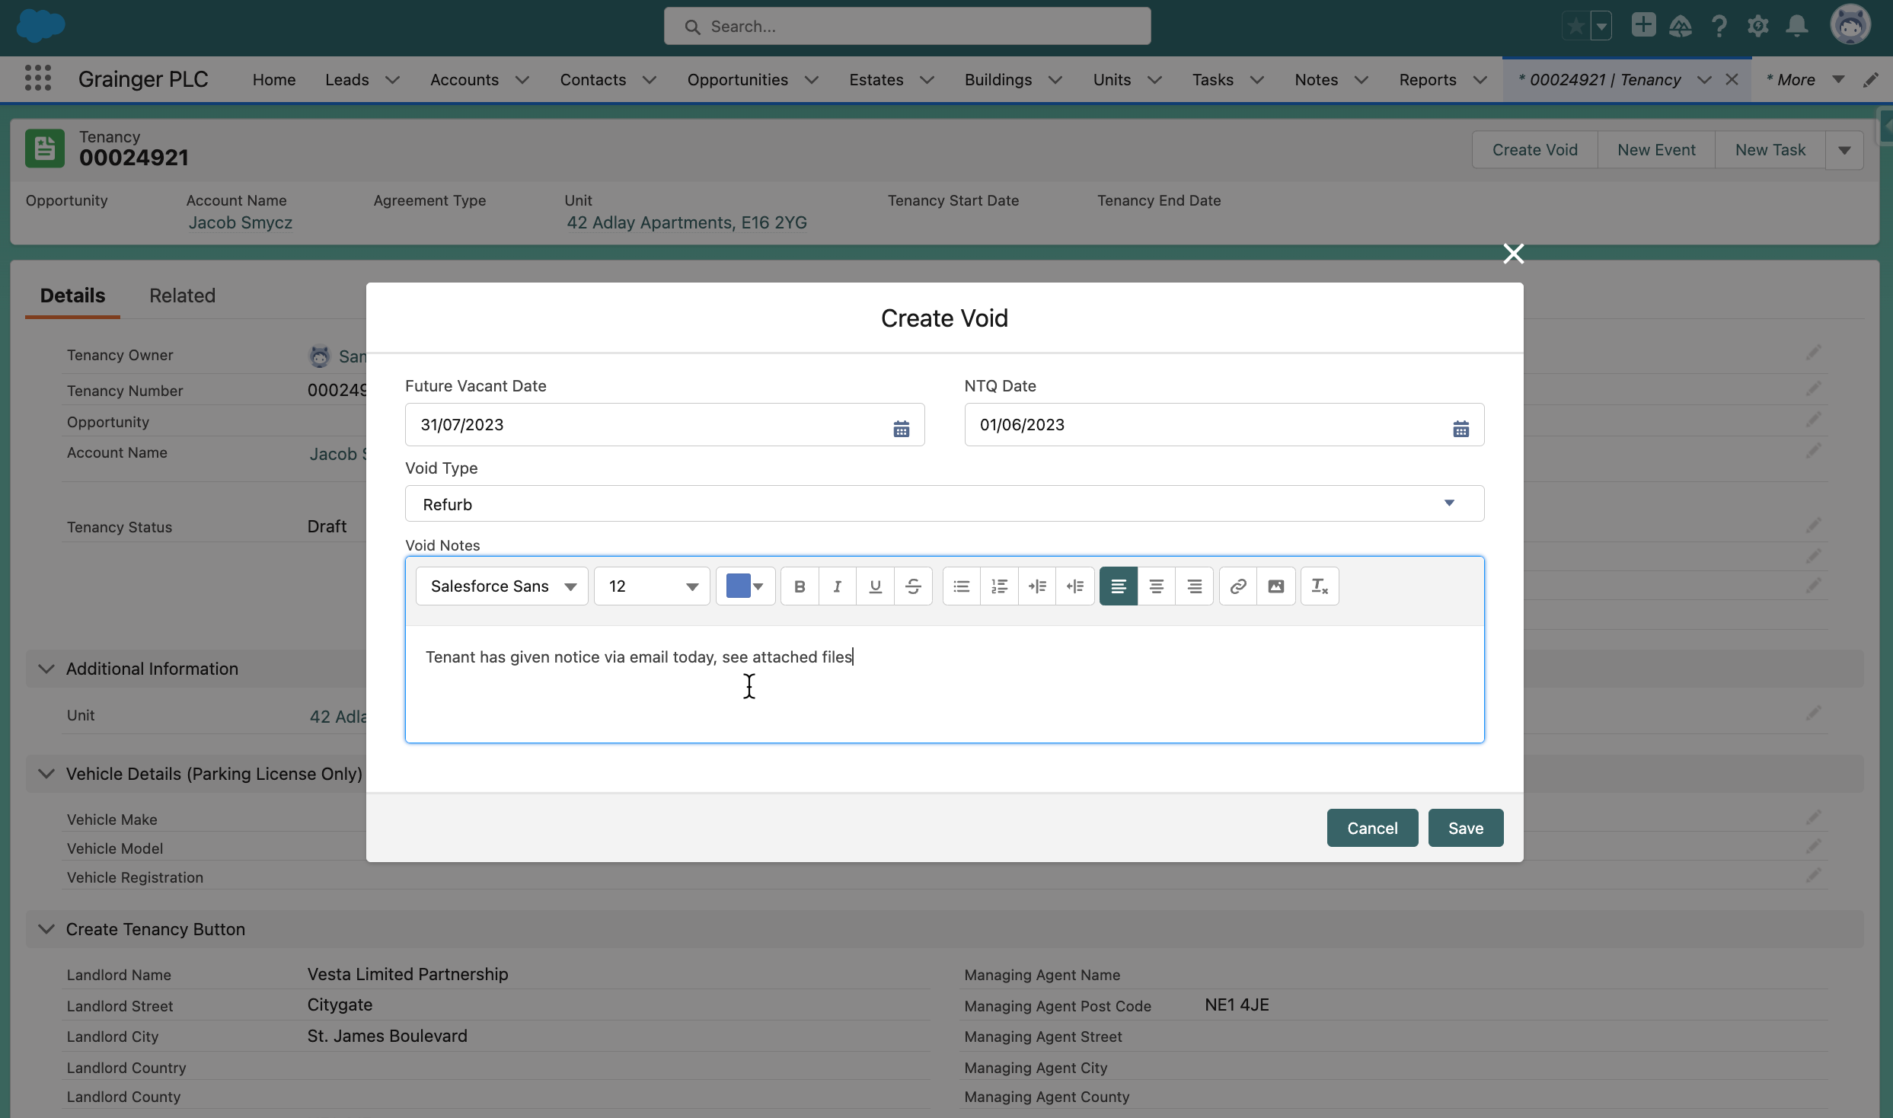
Figure 1: Sample Screen – Initiate a New EOT from the Relevant Tenancy

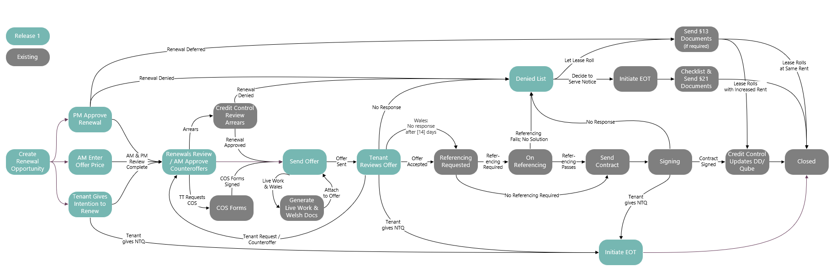

Solution Context

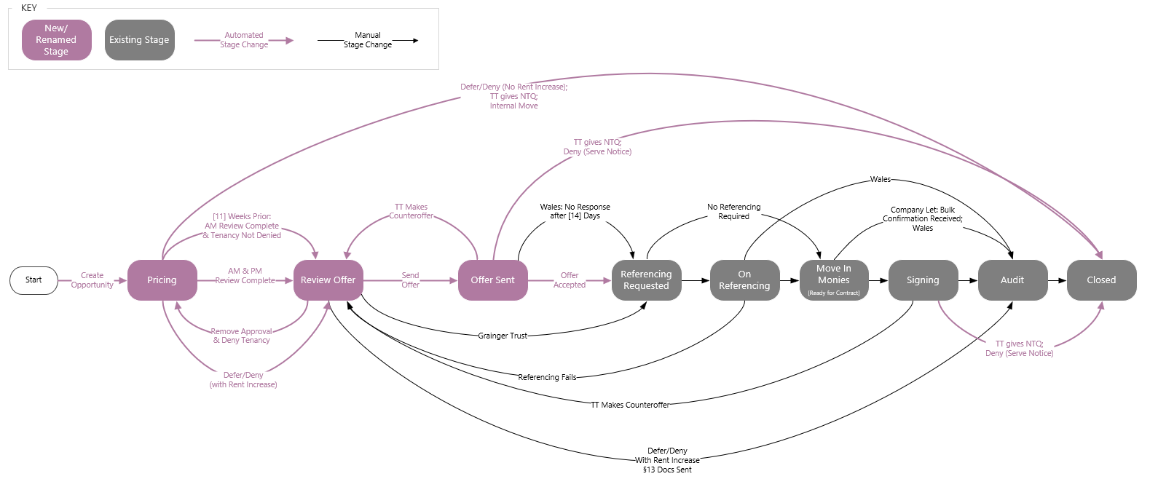

Future State Process Diagram (R1)
The following provides an overview of the solution’s interfaces and users:
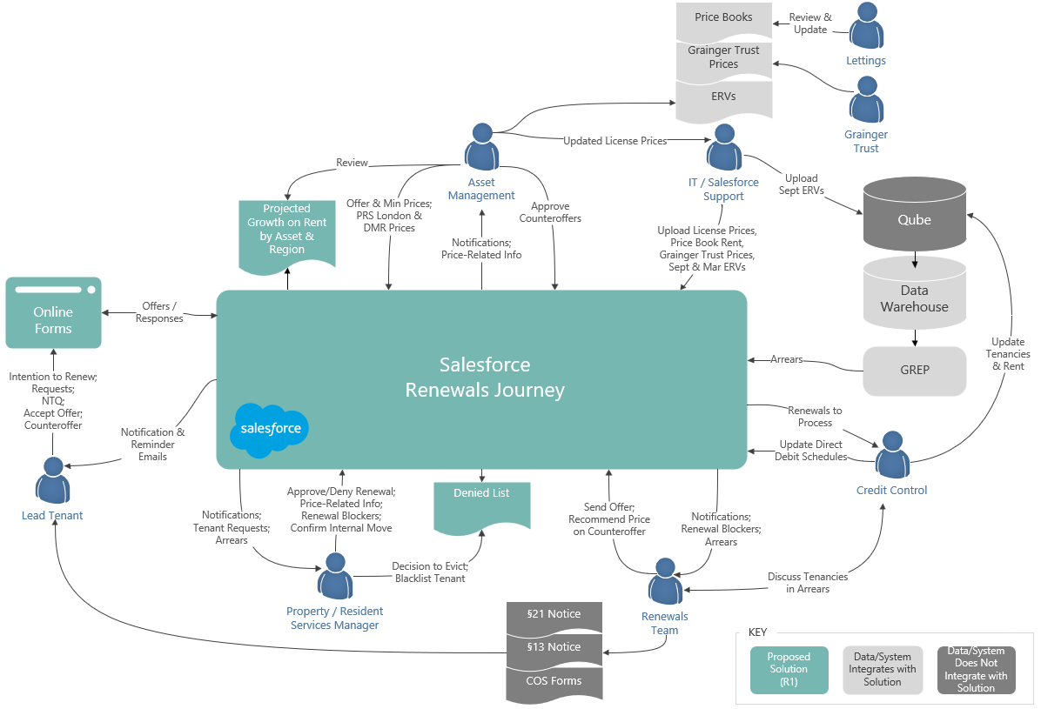
Figure 7: Proposed Solution Context (Release 1)
- Void Management – The solution will be implemented entirely within Salesforce; there will be no direct integration with other systems, other than to utilize Qube data and any other data that is already synced with Salesforce.
- Internal Teams - Users will monitor task lists and other EOT pipeline views, and manually indicate when the EOT-related tasks for which they are responsible are complete.
  - Users may also upload relevant documents & emails to the EOT object.
  - External users, such as tenants or contractors, will not have access to the solution initially.
- Unit - The Salesforce unit data will be kept in sync with the EOT data. The unit provides key information such as the live/work status that informs the EOT process, and the EOT process will update key unit information such as future vacant and available date.
  - While the existing marketing process is not directly integrated with the EOT solution, by keeping the unit’s future vacant and available dates up-to-date, the existing marketing process will be triggered for new EOTs.

Future Functionality / Recommended Project Phasing
Additional functionality that is not included in the initial project scope as outlined above, but which may be addressed in future project releases (see Appendix B – Backlog for Future EOT Releases) includes:
- Integration with Qube, FSI or other data sources.
- Incorporating expected delays into timelines.
- Custom, user-defined tasks.

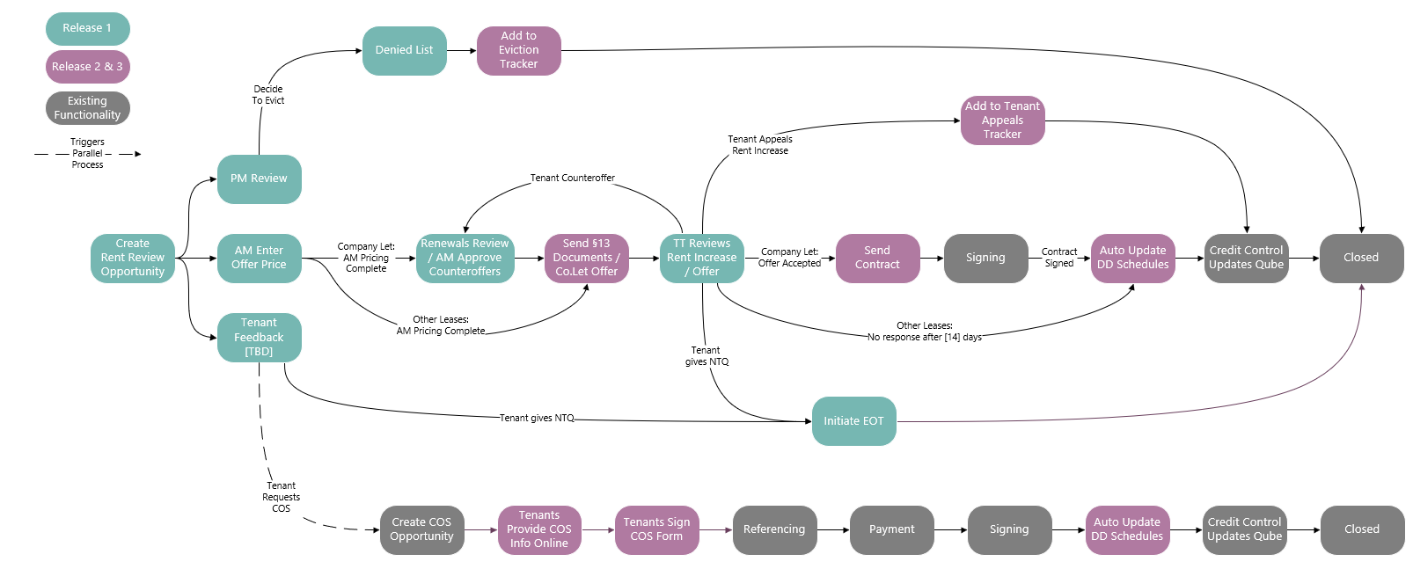

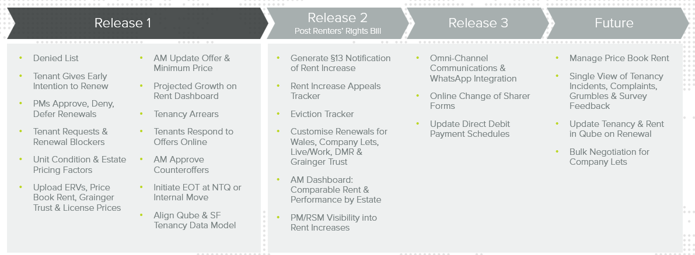

High-Level Design
This document provides a high level design for the proposed Void Management solution to be implemented on Grainger PLC’s Salesforce org.
The design is intended to establish the key architectural decisions that will underpin the solution and ensure that it adheres to the 3 key principles of the Salesforce Well-Architected Framework:
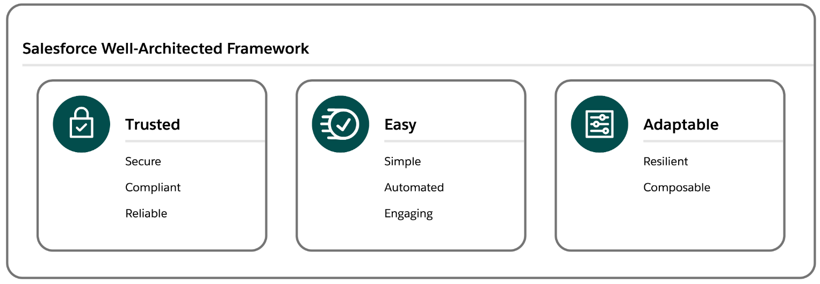
- Trusted solutions protect stakeholders
- Easy solutions deliver value fast
- Adaptable solutions evolve with the business.
This design does not cover the lower level detail (e.g. fields, profiles, automations, validation rules) – these will be designed and documented at user story level during the agile implementation phase.

Salesforce Strategy

Org Information
The Grainger PLC Salesforce org was provisioned in October 2019. It is an Enterprise Edition org with single GBP currency. There are currently 210 Service Cloud licenses, 25 Platform licenses and 40 Partner Community licenses assigned to the org.

Org Strategy
At this point in time there are no requirements (e.g. data residency, large data volumes, autonomous business units etc.) that would require a multi-org strategy, thus the Void Management process will follow a single org strategy and will be implemented on the existing Grainger PLC Salesforce org. Among other benefits, a single org provides the best solution to easily deliver unified processes, a single view of the customer and lower total cost of ownership.

Document/File Management
It is understood that the current document management system (DocuShare) is being retired in June 2024, currently with no replacement having been identified. It is recommended that the Void Management Process make use of Salesforce Files to manage the various documents that are collected and collaborated on. Salesforce Files will allow documents to be attached in context to the records they relate to – e.g. photos of damage to paint work may be attached to a task being created to book maintenance work. This allows easy collaboration and sharing across the multiple teams that are involved in the Void Management Process.

Archival Strategy
Salesforce file and data storage capacity is limited and is determined by a base allocation at org level plus a per-user allocation. Any overage will require the purchase of additional storage from Salesforce. Additionally for data (i.e. records rather than files), a high number of records of any one object can result in large data volume (LDV) performance limitations (report timeouts, slow page loads etc.). Thus it is desirable to operate within the allocated capacity if possible and implement an archival strategy to move data and files off-platform at a point in time where users no longer need to interact with them.
In order to calculate data and file volumes, the following assumptions have been used:
- Number of units: 13 000 in year 1, scaling to ±30 000 in year 5
- Number of voids per year: 1 void per unit
- Number of tasks per void: 40
- Number of files per void: 10
- Average file size: 2MB
Based on these assumptions, the table below shows predicted data and file storage requirements.
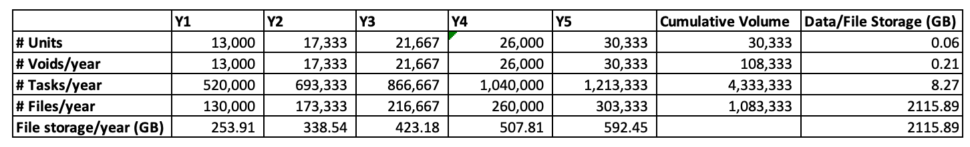
Table 1: Projected File and Data Storage

File Archival
Grainger PLC’s Salesforce org currently has a 503GB file storage limit, of which 66GB is already used. Based on the projected volumes above, this limit would be exceeded in the second year of operation. While not required for the go-live of the Void Management solution, it is suggested that an archival policy be considered so that files can be automatically moved (e.g. via GREP) from Salesforce to a more cost effective storage solution (e.g. SharePoint). Files should be archived at a point in time where users no longer need to interact with them directly from Salesforce, for example 6 months after a void has been completed. File-specific policies may also be implemented, for example the inventory pdf may be retained on the Salesforce platform for longer than photos of painting works.

Record Archival
Grainger PLC’s Salesforce org currently has a 14.8GB data storage limit, of which 7.5GB is already used. Based on the projected volumes above, the data storage limit is likely to be exceeded within the next 5 years. While not required for the go-live of the Void Management solution, it is suggested that an archival policy be considered so that records can be automatically moved (e.g. via GREP) from Salesforce to a more cost effective storage solution (e.g. Azure SQL). Records should be archived (or deleted) at a point in time where users no longer need to interact with them directly from Salesforce, for example 6 months after a void has been completed. Object-specific policies may also be implemented, for example Void records may be retained on the Salesforce platform for longer than the tasks that relate to the void.

Archival Strategy Recommendation
There is no need for the immediate implementation of any archival strategy. Given that the above calculations are based on assumptions, it is recommended that volumes be monitored during the course of operations. Based on actual record volumes a suitable archive strategy and timelines can be planned.

Mobile Strategy
It is recommended that the Salesforce Mobile App be used to provide mobile access where required. There are no offline, branding or native device capability requirements that would necessitate any custom mobile app development.

Reporting Strategy
Operational reporting needs can be met via Salesforce reports. Should deeper analytical capabilities be required in the future, these can be met via a BI solution such as Power BI coupled with an Azure SQL data warehouse.

Form Assembly
Third party application
Security Considerations.

Data Model

Entity Relationship Diagram
The Void Management solution high-level data model is shown below with existing standard and custom objects as already implemented in the Grainger PLC Salesforce.

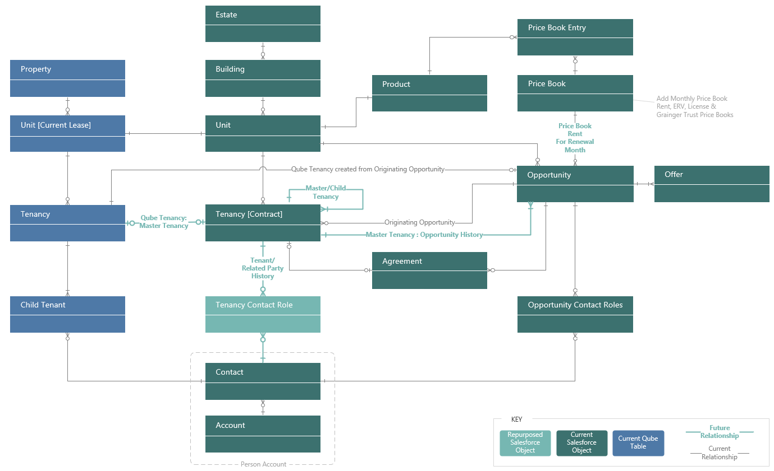

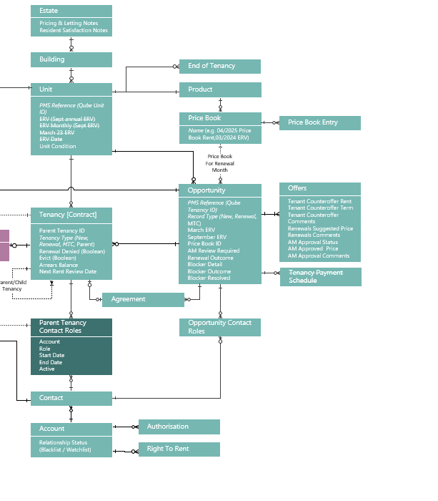
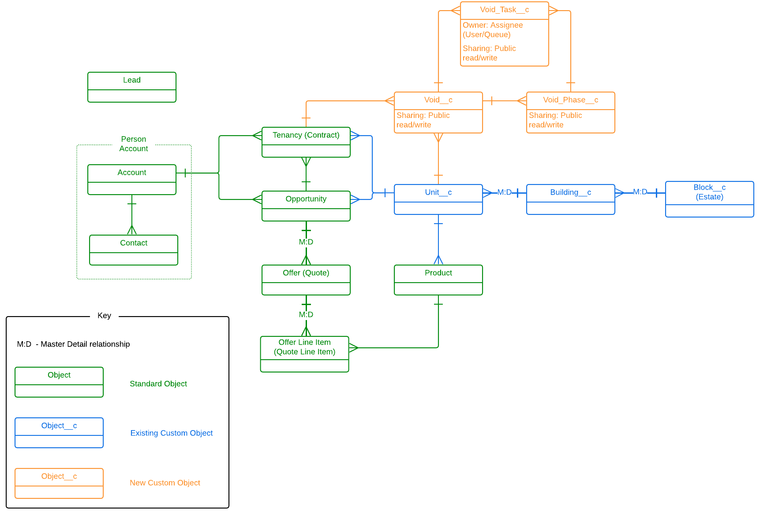
Figure 9: Entity Relationship Diagram

Data Sharing & Security
The Grainger PLC Salesforce org currently has a public read/write org wide default (OWD) for all key objects (Account, Opportunity, Tenancy) and allows all users to view all records. Where no security requirements exist to restrict visibility, this solution provides full visibility to all users and facilitates easy collaboration (e.g. users are able to update tasks belonging to a colleague when the colleague is absent). Based on this, it is proposed that the Void Management objects will follow the same OWD and allow full access to all users. Should future requirements necessitate a tighter security model, this can be implemented with the many security mechanisms provided by Salesforce (role hierarchy, sharing rules etc.).

Integration Approach

Release 1 Integration Requirements
- Daily import of tenancy arrears from Data Warehouse via GREP.
Functionality proposed for release 1 does not require any new integrations between Salesforce and other applications. Release 1 focuses on implementing the void management process within Salesforce, using tasks to track off platform activities (e.g. users will cancel a direct debit in the finance system and mark the Salesforce task as completed).
Existing integrations (e.g. Qube / Salesforce property master data) will be leveraged to ensure the Void Management process aligns with the overarching goal of providing a single view of the customer and property.

Roadmap – Future Integration
Future releases will include integrations to FSI, Qube, Hive and the Grainger Portal (and other systems as identified). Where possible, all integrations should be implemented via the GREP integration layer to:
- Ensure a decoupled architecture
- Take care of routing and error handling
- Fall under existing Grainger standard operating procedures (SOP)
- Support complex transformations
- Efficiently handle large data volumes
It is understood that various integration initiatives are already in progress (e.g. automated lease creation in Qube triggered by Tenancy in Salesforce). The Open Box implementation team should work closely with Grainger PLC to ensure the roadmap is aligned and supports the Void Management roadmap.

Data Migration
The current state Void Management process is largely manual. There is no source of void data that could be feasibly migrated to Salesforce. As the Salesforce Void Management solution goes live, users will start using it to create new voids. Any in progress voids should be completed using the current manual process.
All data is either assumed to already exist in Salesforce or will be created via the Void Management functionality. It is assumed that the existing Salesforce customer and property data is of a sufficiently high quality to support the Void Management process. No cleansing, enriching or de-duplication is planned.

- From Qube
  - Unit condition from Qube
  - Denied status from Qube diaries
  - Next lease end diary date = next rent review date (for rolling leases only)
- Create price book rent records for:
  - All existing price books
  - Grainger trust
  - All existing license units with current prices.
  - Latest Sept & March ERV Files

Salesforce Licensing
It is understood that all users of the first release of the Void Management solution have already been provisioned with full Salesforce licenses. It should therefore not be necessary to purchase additional licenses.
It is not expected that the solution will require any additional costs for data and file storage. This is based on current understanding and scoped features and is subject to change if additional requirements (e.g. file storage) are introduced.
Future functionality may involve additional users (e.g. external contractors to be assigned inspection tasks), in which case requirements would need to be evaluated to determine the most suitable license types (e.g. customer community vs. customer community plus). Grainger PLC would need to purchase these from Salesforce.

Support
Open Box will provide post-go-live support for 10 working days immediately following the production deployment.
Where additional or ongoing support, enhancements and maintenance of the solution is required:
- A separate support agreement will be required, or
- If Grainger chose to extend Open Box’s services, support may be incorporated into the backlog.

Training
To facilitate the training process, Open Box will train a designated Grainger representative.
Open Box will not provide any end-user documentation, change management or end-user training; this will be the responsibility of Grainger.

Exclusions and Limitations
The following is not included in the cost or scope of this project:
- Multi language and multi-currency are not required for this solution.
- Solution documentation, other than user stories.
- Salesforce costs, license fees, subscriptions or services
- The following functionality is not expected to be required in the initial, or future, releases:
  - Different workflow between BTR & PRS properties
  - Document generation
  - Notifications are limited to creating tasks that users can see. There is no need to generate reminder/notification emails from the system.
  - Integration with:
    - Inventory Hive
    - Datawarehouse for reporting
    - Proactis (AP)
    - New integration with Adobe Sign
- Only the browsers detailed within Salesforce Help will be supported by the web solution.

Assumptions
The following will not be required as part of the annual rent increase process, once the Rent Reform Bill becomes law:
- Generating, sending & signing of renewal contracts for the majority of units.
  - Company Lets and Live Work [TBC] will still require contracts.
- Reviewing RTR before sending notification of rent increases.
  - Will be a separate process.
- Reviewing arrears before sending notification of rent increases.
  - Monitoring & managing arrears will be a separate, ongoing process.
  - Sourcing the current arrears balance for a tenancy from Qube/data warehouse in release 1 still adds value; this is an important data point to have in Salesforce for the single view of customer.
- Processing COS and other lease changes (payment frequency, addition/removal of guarantor) as part of a rent increase as part of the rent increase.
  - Will not hold up the rent increase process; will be a separate, potentially parallel process.
- TBC - Asking the tenant if they plan on remaining in the apartment / would like different lease terms / have issues upfront.
  - The tenant must always give 2 months notice; there isn’t the urgency to get NTQ 2-3 months before lease end date anymore.
  - There is still value in doing a MVP version of this for release 1 to reduce void days in the meantime.
- Dealing with tenant complaints / requests / issues / request to move to a different unit as part of a rent increase.
  - Will not hold up the rent increase process; will be a separate, potentially parallel process.
- Issuing Section 21 documents & completing the §21 checklist.
  - A different eviction process will be required.
  - Will also be a separate rent appeals process/tracker.
- PM approving renewals.
  - PM input will be optional and largely limited to pricing-related comments.
- Ability to defer a renewal.
  - Rent increase cannot be deferred for 3/6 months anymore.

Prerequisites

Detailed Costs
Open Box will provide the following services:
- An agile sprint team delivering sprints at a cost of £35 100 per sprint.
  - Release 1 is currently projected to require 4 sprints (£140 400)
  - The team will be staffed to include the following skill sets as required:
    - Salesforce Technical Architect
    - Business Analyst
    - Developer
    - Quality Assurer
    - Project Managers
- UAT support at a minimum cost of £1, 800 per week.
  - Open Box has included 2 weeks (10 days) of cover to be provided to support the UAT process and fix any new bugs identified (£ 3 600).
  - UAT support will be billed for the duration of the UAT period (i.e., from the end of the final sprint until UAT sign-off by Grainger) on a pro-rata basis.
- Production deployment & and post-go live support at a minimum cost of £1 800 per week.
  - Open Box has included 2 weeks (10 days) cover to be provided immediately following the production deployment (£ 3 600).
The project is expected to start on 4th September 2023 and require 4 sprints to complete development as well as 2 weeks for UAT.
- The total cost of Release 1 is therefore estimated to be £ 147 600.
- The total duration of Release 1 is expected to be 14 weeks as well as an additional 2 weeks for post go-live support.

Release 1 Phases | Expected Start Date | Duration | Estimated Cost (GBP)
Sprint 1 | 4th September 2023 | 3 weeks | £ 35 100
Sprint 2 | 25th September 2023 | 3 weeks | £ 35 100
Sprint 3 | 16th October 2023 | 3 weeks | £ 35 100
Sprint 4 | 6th November 2023 | 3 weeks | £ 35 100
UAT | 27th November 2023 | 2 weeks | £ 3 600
Production Deployment & Post Go-Live Support | 11th December 2023 | 2 weeks | £ 3 600
Release 1 Total |  | 16 weeks | £ 147 600

All amounts are quoted in GBP (£) and exclude VAT, if applicable.
Project costs will be billed monthly, in arrears.
This quotation is valid until 31st August 2023. Open Box will require sign-off on this Statement of Work by this date in order to meet the anticipated 4th September 2023 start date.
All consultancy and all development work will be completed by Open Box offsite.
- It is not expected that the project requires Open Box resources onsite. Where onsite personnel are required, all reasonable expenses for travel and subsistence shall be reimbursed by Grainger. Open Box shall not bill any mark-up or administration fee onto any such expenses. Approval for expenses shall be obtained from Grainger prior to being incurred.

Extension of Service Period
The provision of these services may be extended - by mutual agreement of Open Box and Grainger PLC - at the rates above. Email communication is considered sufficient and binding for this purpose.

Dependencies
Costs and timelines are contingent on:
- Grainger PLC identifying the appropriate personnel and stakeholders to be involved in the project, and them available throughout the project, including participation in the activities (and within the timelines) detailed in the Delivery Approach.
- There are no other projects planned or in operation that may hinder this project.

Delivery Approach
The delivery approach will be based on the agile SCRUM framework. Iterative delivery is achieved through a series of 3-week sprints.
An agile delivery approach allows for the early delivery of outcomes and provides flexibility to adjust for any unforeseen opportunities or issues uncovered during the project.
A backlog will be maintained to track outcomes to be delivered and indicate priority of these outcomes relative to each other. The backlog will be a living artifact that will evolve as Open Box and Grainger collaborate and will serve as the single source of truth with regards to scope.
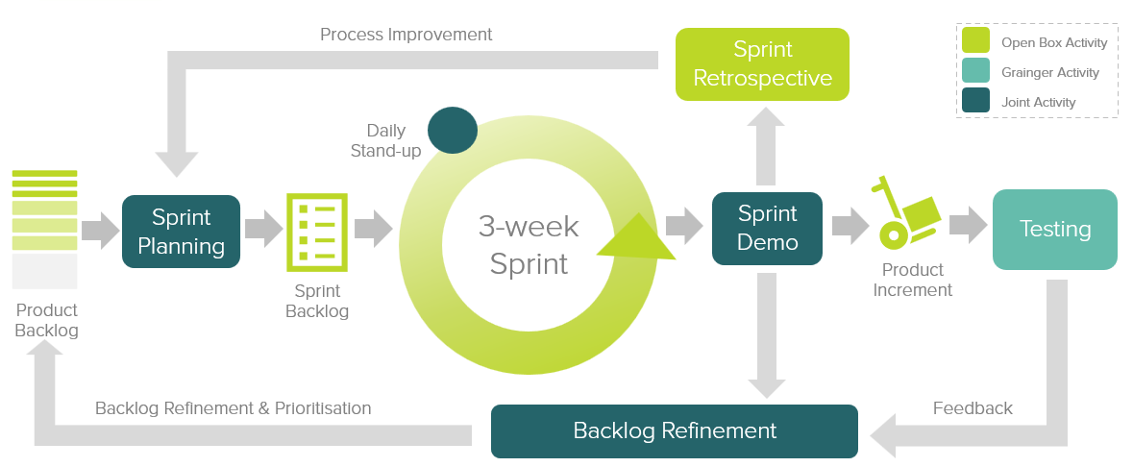
Figure 10: Agile Delivery Approach
Grainger representatives will be required to particulate in the following during each sprint cycle:
- Backlog Refinement – Open Box and Grainger representatives will meet to prioritise user stories on the backlog as well as review and agree on acceptance criteria for user stories at the top of the backlog.
- Demo – Open Box will meet with Grainger representatives to demonstrate the outcomes delivered in the past 3-week period.
- Sprint Planning – Outcomes on the backlog will be selected for the next 3-week period.
- Testing – Open Box will be responsible for unit testing and QA testing of functionality. Grainger representatives will conduct user acceptance testing of new functionality delivered in each sprint and provide feedback within 1 week of the demo.
- Stand Up’s – Regular, 15-minute stand up calls will be held to report on progress; the Grainger product owner is expected to participate regularly in these calls to provide feedback and give input on any questions that arise.
Grainger feedback from demos and testing will be classified as either bugs or enhancements (depending on the user story and acceptance criteria). Bugs will be fixed in a subsequent sprint, whereas enhancements will be incorporated into the backlog and prioritised accordingly.

UAT
Designated Grainger business users will be given access to a UAT sandbox to test the functionality end-to-end and ensure that the overall solution is functioning as expected.
Issues raised will be classified as bugs or enhancements (as above). Bugs will be fixed during the UAT period. Any other enhancements or new requirements will be added to the backlog for future development.

Project Management
Open Box will deliver a progress report to Grainger on a regular basis, that will include:
- General status update
- Project risks
- Project milestones and timeline forecast based on the current scope of release 1.
Regular updates regarding any significant changes in scope or cost will be delivered to Grainger as and when they occur.

Availability
- Open Box resources will be contactable and available for meetings via conference calls/video conferences:
- Monday to Friday 9AM – 6PM South African time (GMT +02:00) which currently corresponds to 8AM – 5PM (BST), excluding public holidays.
- A defined escalation path will be provided to the agreed Grainger project manager / product owner should urgent assistance be required outside of these times.

Acceptance
The parties hereto, each acting under due and proper authority, have executed this Agreement as of the day, month and year first written below.

For and on behalf of Open Box Software For and on behalf of Grainger plc

Signature: _____________________ Signature: _____________________
Name: _____________________ Name: _____________________
Position: _____________________ Position: _____________________
Date: _____________________ Date: _____________________

